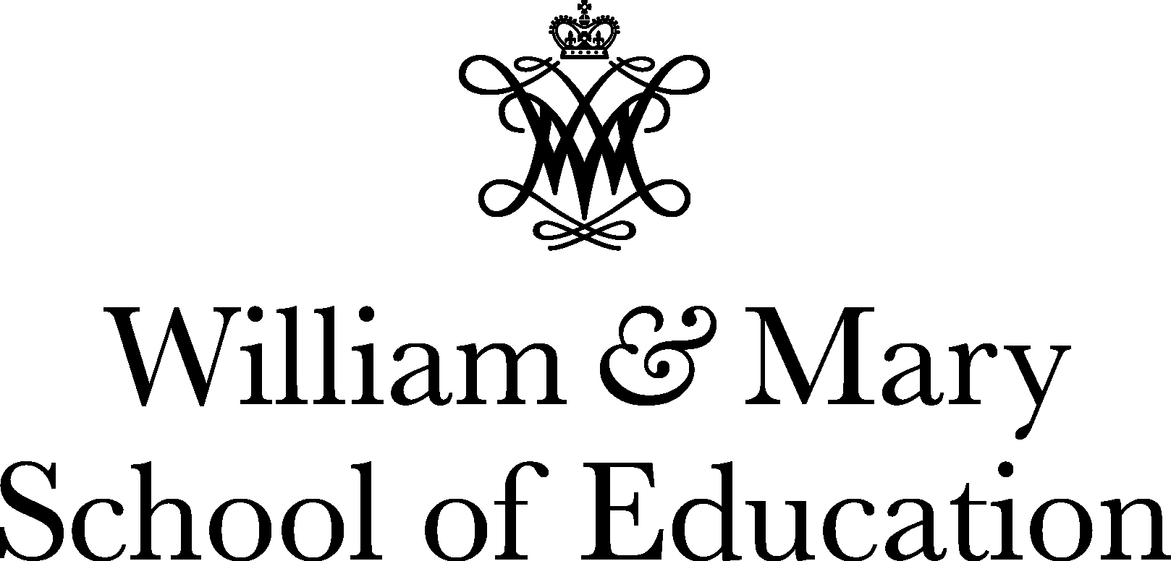
School-University Resource Network
Amy C. Colley, Executive Director
P.O. Box 8795, Williamsburg, VA 23187-8795
Phone: 757-221-2353
SURN@wm.edu

2023 - 2024 SURN Principal Academy
Program Information & Registration Agreement – 2022 Cohort Year Two

Initiative Information
SURN Principal Academy registration is open for the 2022 cohort of principals and/or assistant principals to continue in year two of the SURN Principal Academy. We are eager to assist them again this year! Principals will continue to grow their leadership skills to:
- increase student engagement and deeper learning;
- improve the supervision and feedback cycle between teachers and principals;
- model exemplary, standards-based professional learning;
- provide tools for data collection, observations, feedback, and leading professional learning; and
- capitalize on collaboration and collegiality as principals learn from leaders, coaches, mentors, and peers to navigate ongoing changes and challenges in K-12 school leadership.

SURN partner superintendents or assistant superintendents are invited to authorize principals and assistant principals to continue in this yearlong professional development series. For each principal selected, please fill in the registration form, and sign the agreement.

Knowing that the principal is second only to the teacher in a school’s student achievement, and knowing the critical role principals play in teacher retention, the time is now to prioritize principal professional learning. Please note: SURN continues to actively seek out external funding, prioritizing the SURN Principal Academy. Currently no grants fund this work; however, we have worked hard with the budget and are not raising the price of registration.

The cost for this year is $4,200 billed in two equal installments, due November 17, 2023, and February 24, 2024. SURN will invoice the division upon receipt of the registration information. Note: divisions are welcome to pay based on the budget needs of the division, including prior to June 30, 2023.

Participants receive:

- 4 interactive professional learning days at William & Mary School of Education;
- 2 impact coach sessions;
- a principal coach for small group coaching to include 3 synchronous remote meetings;
- opportunity for collaborative site visits with coaching team;
- access to e-Observations online for conducting and compiling academy observations (your principals are trained in this and we will continue to provide access);
- principal support and academic optimism (collective self-efficacy, trust, and academic press) survey administration, results, and interpretation;
- professional books, articles, and materials; and
- ongoing, high-quality professional learning from William & Mary School of Education faculty and professionals.

Registration Information

SURN Partner School Division: ______________________________________________________________________

Principal/Assistant Principal’s Name: ______________________________________________________________________

Selected Principal/Assistant Principal’s Email Address: ______________________________________________________________________

The administrator is a/an (check) __assistant principal __principal

School Name: __________________________________________________________

School Level (check) __elementary __middle __high

As the superintendent/designee, I agree to support the principal whom I support by:

- Notifying the principal whom I select to continue in the 2021 cohort of his/her nomination, and explaining my expectation for full participation in all sessions. SURN will follow up with the principal with details as well.
- Authorizing professional leave for four days (September 21 & November 9, 2023, and February 22 & April 25, 2024) throughout the academic year to participate in leadership development sessions with SURN at William & Mary School of Education.
- Authorizing and supporting principal use of SURN observation protocols to collect data for teacher feedback.
- Authorizing and supporting principal administration and use of teacher survey of indicators of principal support and academic optimism.
- Authorizing professional leave for online coaching sessions (October 2023; January & March 2024).
- Authorizing professional leave for collaborative observations with team (2).
- Designating funds and agreeing to pay the Principal Academy invoice.
- Contributing to the cost of the Principal Academy by providing the principal with a device that can readily connect to the school network to access the web-based observation tools.

Superintendent/designee’s Signature ____________________________________________ Date______________________

Email signed forms to SURN@wm.edu by August 31, 2023.

